Software Design Document

AI Based Crop Disease Detection System



Submitted by
Muhabbat Ali Khan (F22BINFT1E02100)

Submitted to

Mr. Muzamil ur Rehman

Department of Information Technology

Faculty of Computing

The Islamia University of Bahawalpur

Meeting Details
Sr No | Details | Date | Supervisor Signature

1. Introduction
1.1 Purpose
1.2 Scope
2. System Architecture
3. Module Design
3.1 User Management Module
3.2 Image Upload Module
3.3 Disease Detection Module
3.4 Treatment Module
3.5 Admin Dataset Management Module
4. Sequence Diagrams
4.1 Upload Leaf Image & Disease Detection
4.2 User Sign-Up
5. Database Design
6. Technologies
7. Non-Functional Design
8. Component Diagram – Disease Detection System
9. Activity Diagram – Disease Detection Workflow

1. Introduction

1.1 Purpose
The purpose of this SDD is to describe the design of the AI-Based Crop Disease Detection System, which detects crop diseases from leaf images and provides treatment suggestions. It serves as a reference for developers, testers, and maintainers of the system.

1.2 Scope
This system supports detection and classification of crop diseases for crops like wheat, rice, maize, tomato, and potato using AI models (CNN). It provides a web interface for users and can later integrate with mobile apps.

2. System Architecture
The system follows a 3-tier architecture:
- Presentation Layer: Web and mobile interfaces for Farmers and Admins (Flutter for mobile, web-compatible UI).
- Business Logic Layer: FastAPI backend handling user management, image processing, and AI model prediction.
- Data Layer: PostgreSQL database for storing users, image uploads, detection results, and datasets.

High-Level Architecture Diagram (PlantUML):
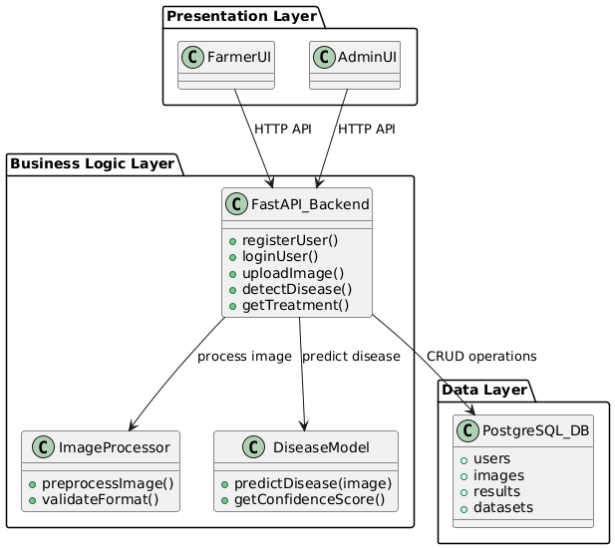

3. Module Design

3.1 User Management Module
- Responsibilities: Handles user registration, login, authentication.
- Classes:
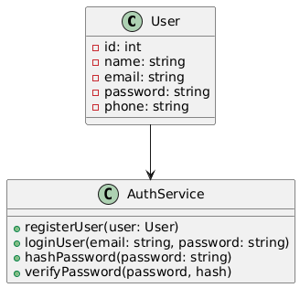

3.2 Image Upload Module
- Responsibilities: Accepts leaf images, validates format, stores image in DB/storage.
- Classes:
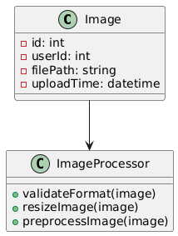

3.3 Disease Detection Module
- Responsibilities: Runs the AI model (CNN) on uploaded images and returns disease predictions.
- Classes:
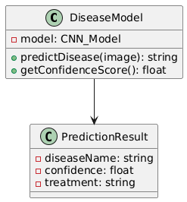

3.4 Treatment Module
- Responsibilities: Provides disease description and treatment suggestions.
- Classes:
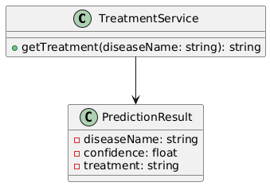

3.5 Admin Dataset Management Module
- Responsibilities: Admin can manage datasets for training and retraining the AI model.
- Classes:
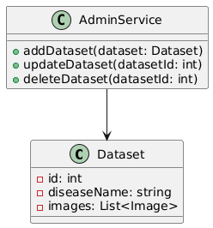

4. Sequence Diagrams

4.1 Upload Leaf Image & Disease Detection
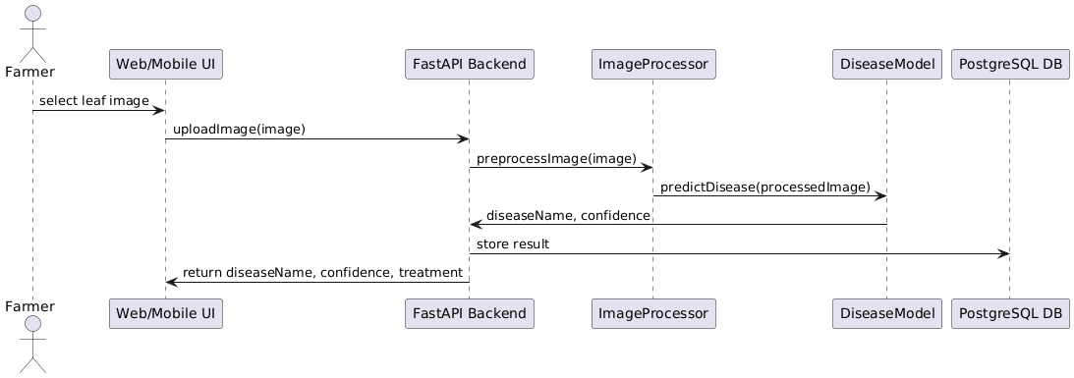

4.2 User Sign-Up
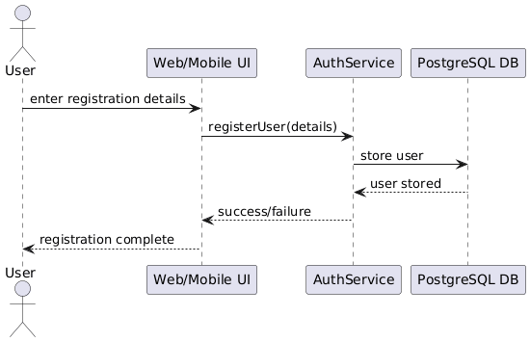

5. Database Design
Tables:
- Users
  - id (PK), name, email, password_hash, phone, role
- Images
  - id (PK), user_id (FK), file_path, upload_time
- Results
  - id (PK), image_id (FK), disease_name, confidence, treatment
- Datasets
  - id (PK), disease_name, image_paths

ER Diagram:
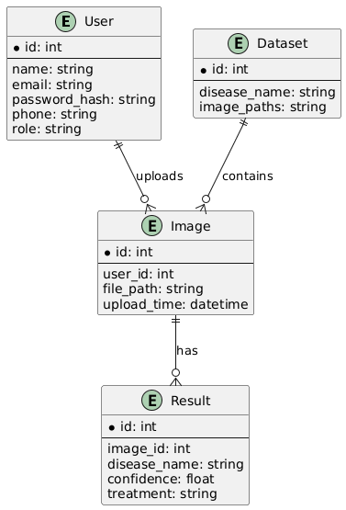

6. Technologies

Layer | Technology
Frontend | Flutter
Backend | FastAPI (Python)
AI/ML | TensorFlow, Keras, OpenCV
Database | PostgresSQL
Dataset | PlantVillage
Platform | WebApplication

7. Non-Functional Design
- Performance: Results within 5 seconds
- Scalability: Modular design allows adding new crops and diseases.
- Security: Secure password storage, HTTPS, role-based access control.
- Reliability: High availability through containerization or cloud deployment.
- Usability: Simple, mobile-friendly UI for farmers.

8. Component Diagram – Disease Detection System
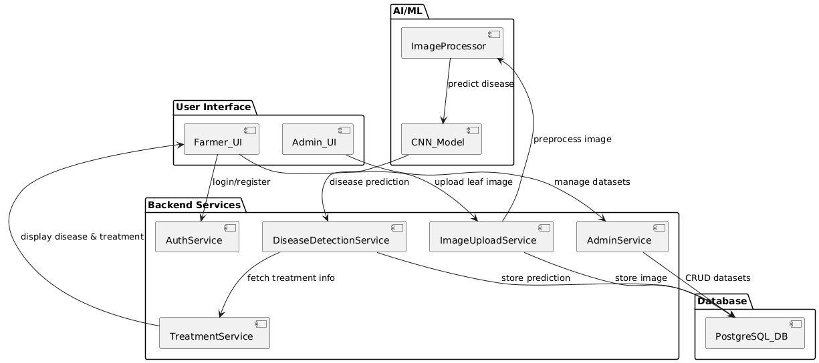

9. Activity Diagram – Disease Detection Workflow
